Question 5

The sample frequency of the signal is 44.1kHz, and the disturbance situated at 330Hz.

To design a second order IIR notch filter, the bandwidth in 3dB is 0.1π, 0.01π and 0.005π.

To calculate the filter coefficients, the transfer function of second order IIR notch filter is,

$$H_{BS}\left(z\right)=\frac{1+α}{2}∙\frac{1-2βz^{-1}+z^{-2}}{1-β\left(1+α\right)z^{-1}+αz^{-2}}$$

$β=cos⁡(ω_{0})$, $ω_{0}$ is the notch frequency where the disturbances situate.

$\cos\left(B_{w}\right)=\frac{2α}{1+α^{2}}$, $B_{w}$ is the bandwidth at 3dB.

So the $ω_{0}=\frac{2×330×π}{44100}$,

If $B_{w}=0.01π$, the transfer functions is:

$$H_{BS1}\left(z\right)=\frac{0.6503z^{2}-1.2991z+0.6503}{z^{2}-1.2991z+0.3005}$$

If $B_{w}=0.01π$, the transfer functions is:

$$H_{BS2}\left(z\right)=\frac{0.9529z^{2}-1.9038z+0.9529}{z^{2}-1.9038z+0.9590}$$

If $B_{w}=0.01π$, the transfer functions is:

$$H_{BS3}\left(z\right)=\frac{0.9759z^{2}-1.9497z+0.9759}{z^{2}-1.9497z+0.9518}$$

Based on the conditions above, using the bandwidth 0.1π in 3dB,

The pole/zero map of the filters and its magnitude and phase response show below:

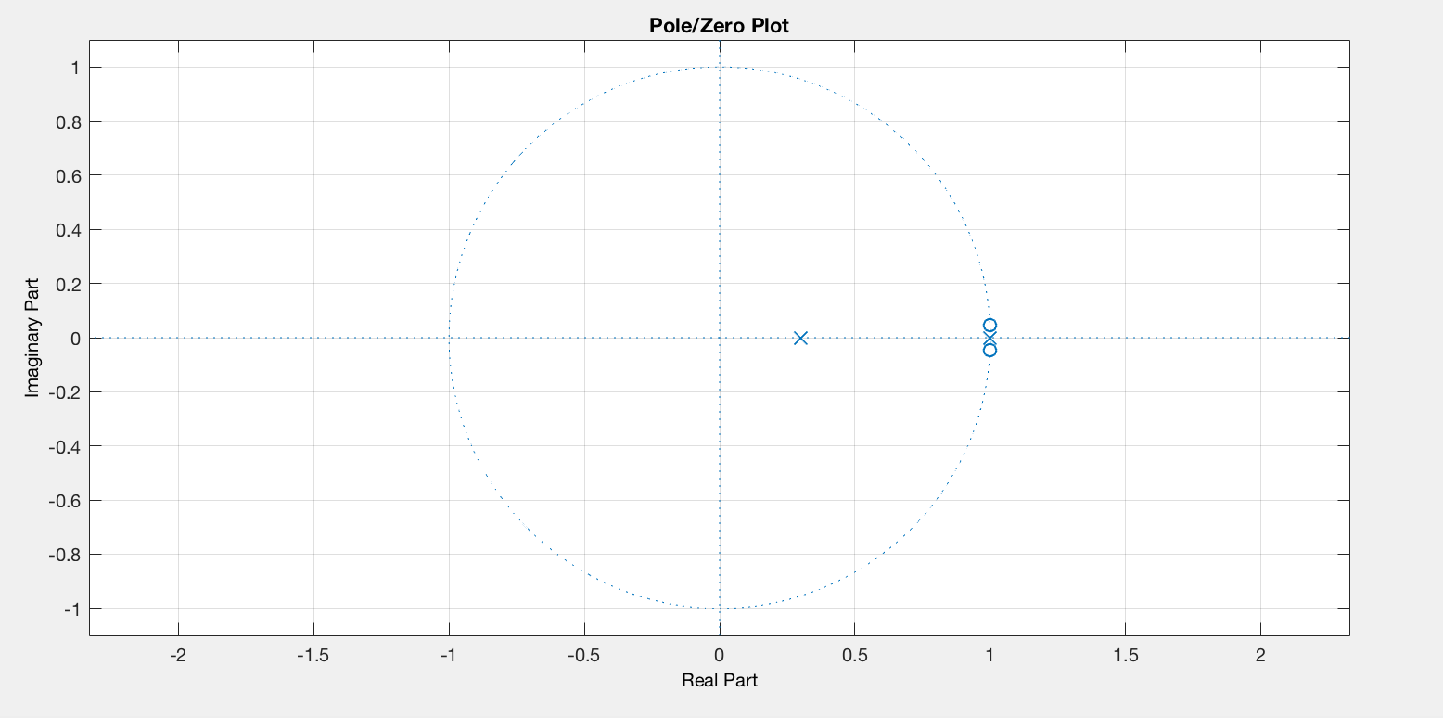

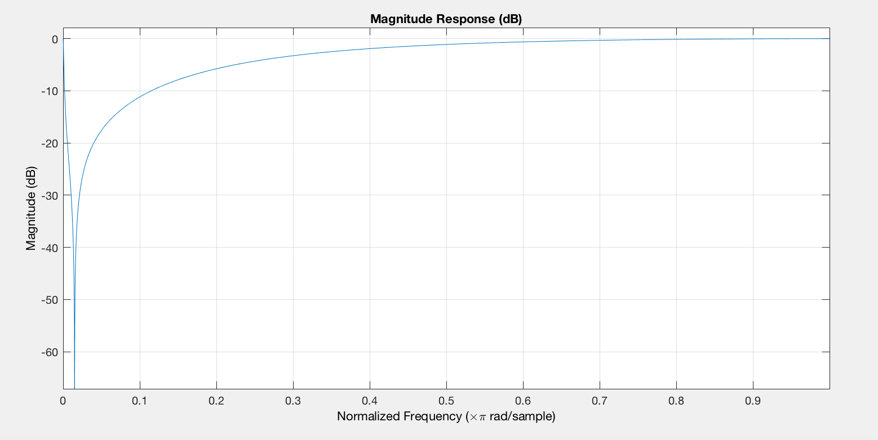

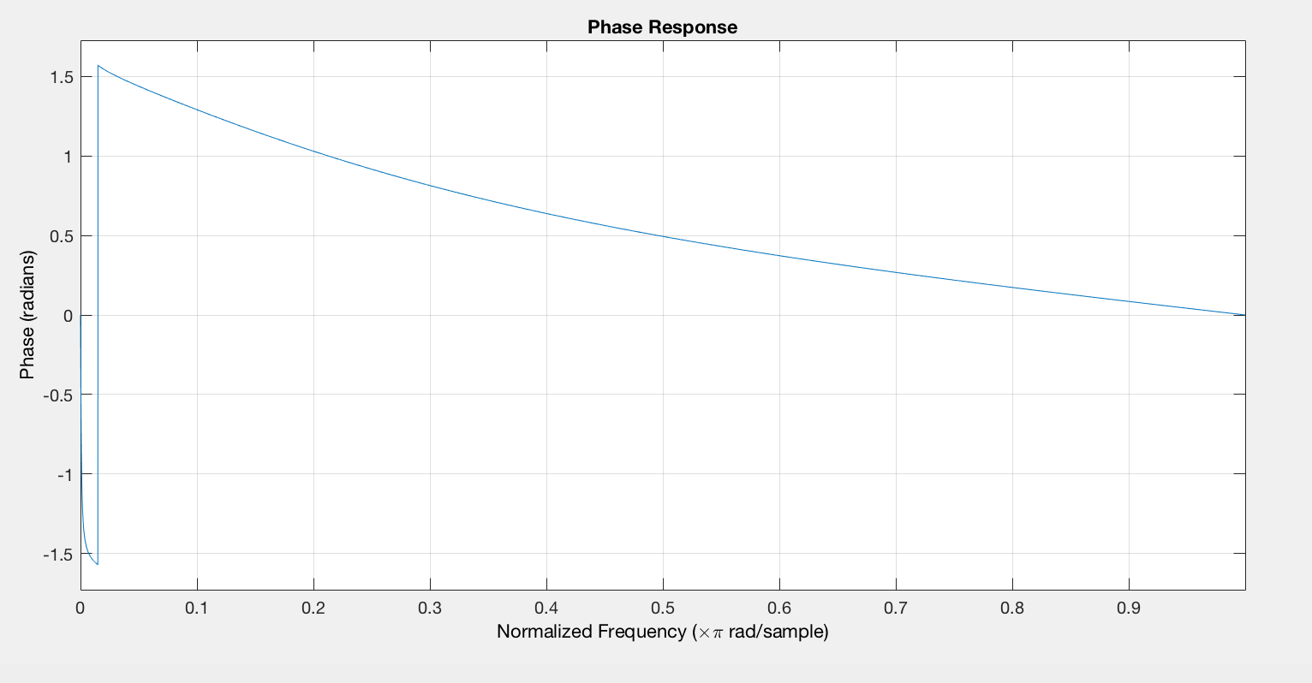

Based on the conditions above, using the bandwidth 0.01π in 3dB,

The pole/zero map of the filters and its magnitude and phase response show below:

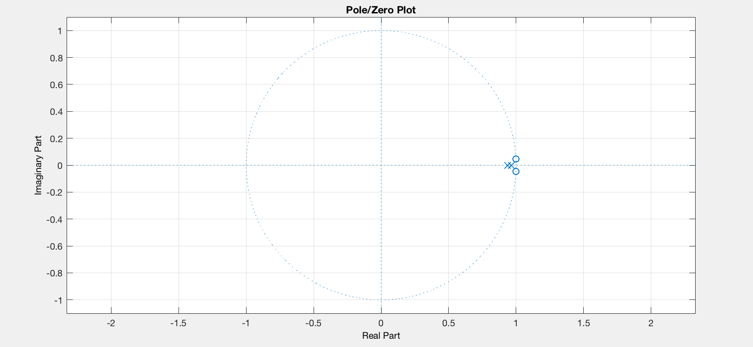

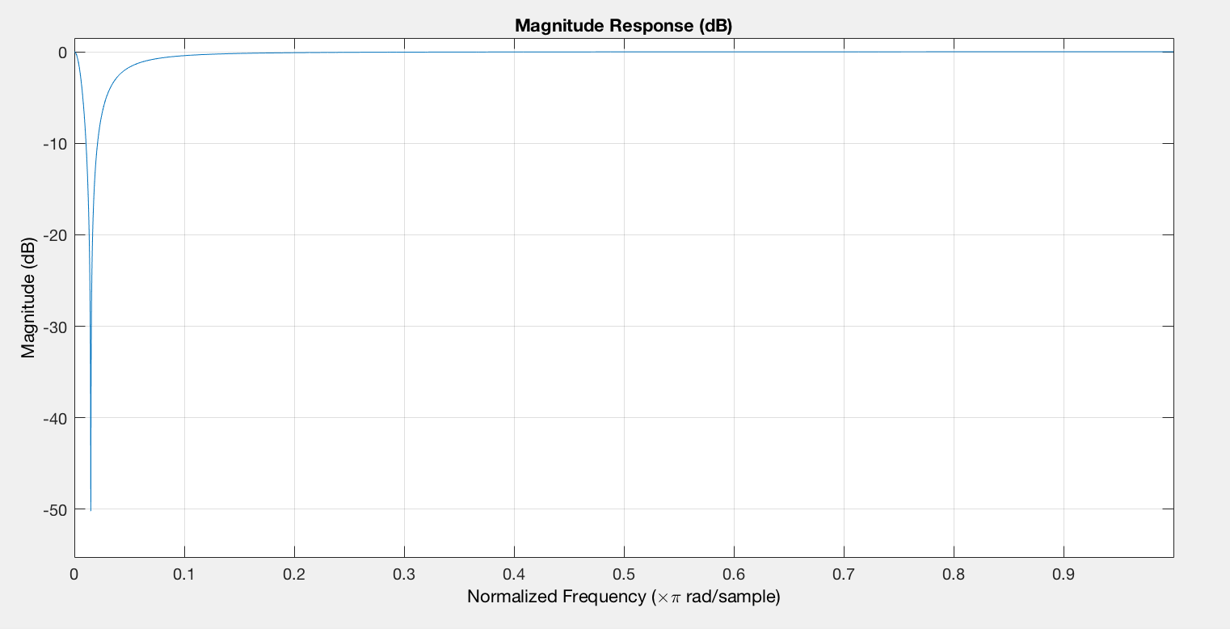

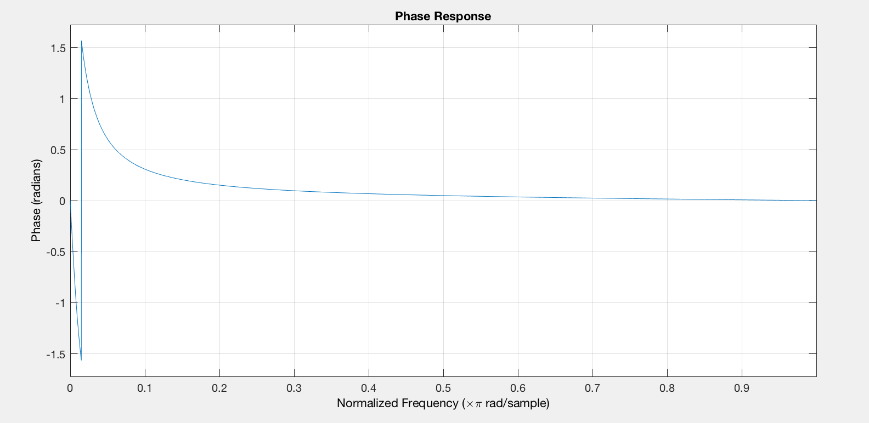

Based on the conditions above, using the bandwidth 0.005π in 3dB,

The pole/zero map of the filters and its magnitude and phase response show below:

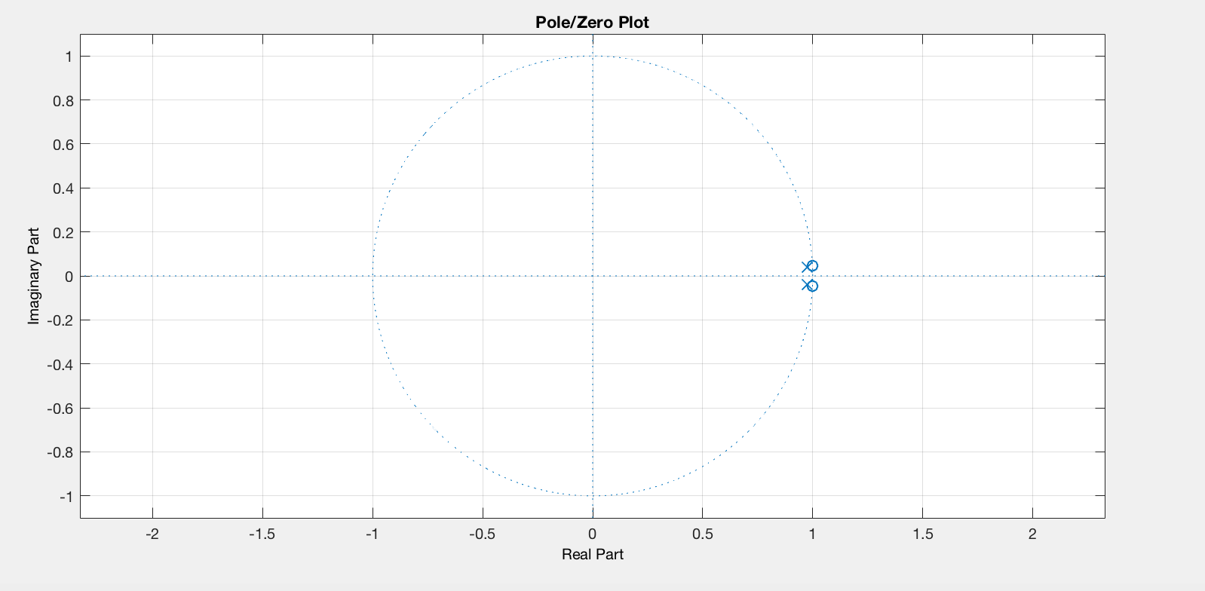

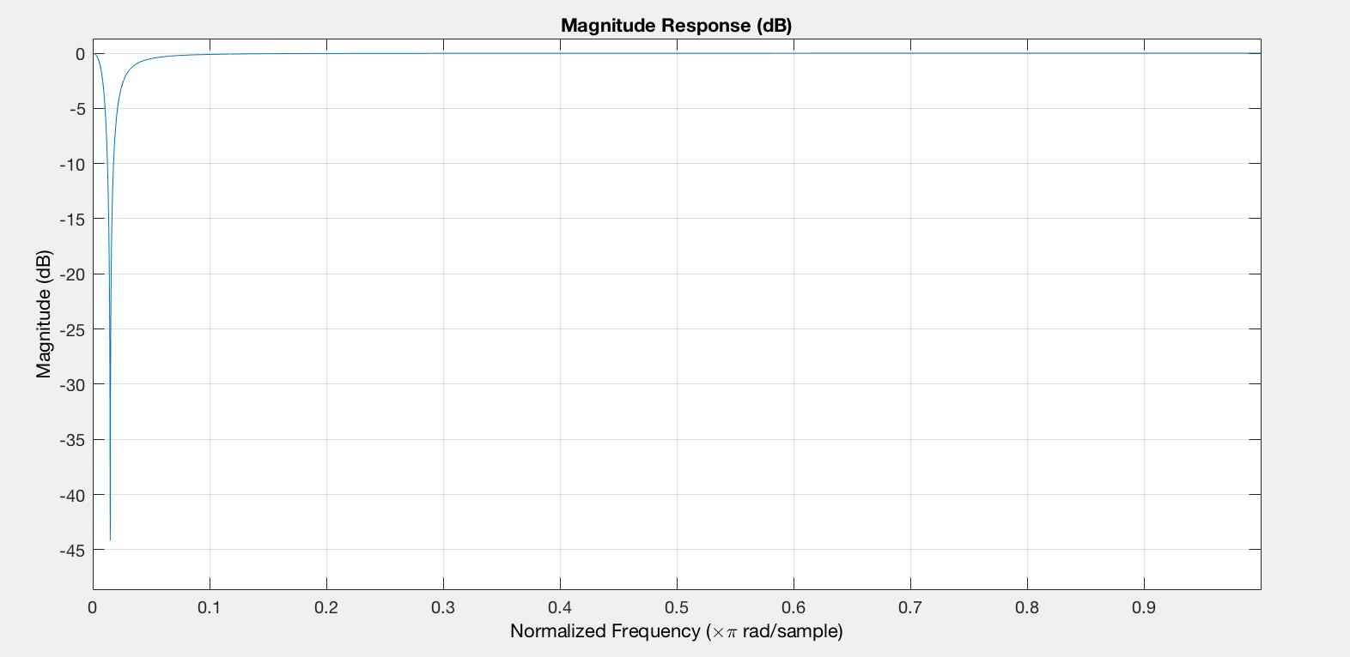

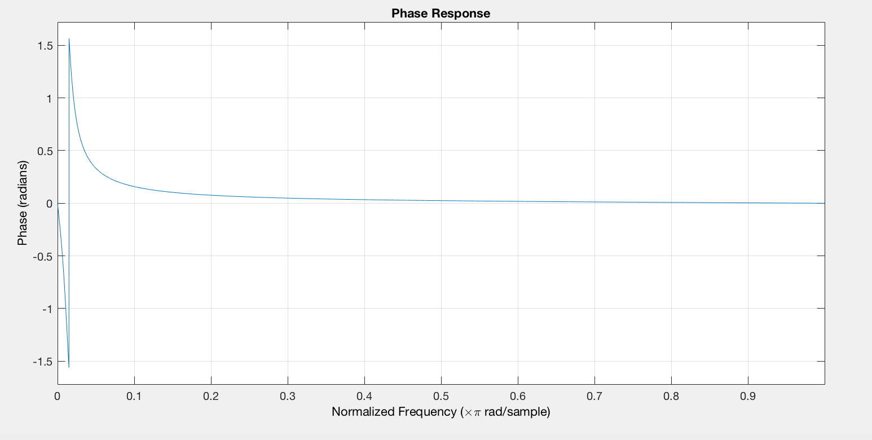

Concentrate on the pole/zero map of the filter, with the decrease of the bandwidth at 3dB,

the position of zeros do not change. While the poles are closer to the positions of zeros, it indicates that if the IIR has shorter bandwidth at 3dB, then the poles and zeros will be more concentrated.

In term of magnitude plot of the IIR notch filter, as the bandwidth at 3dB decreases, it can easily be observed that the range of notch on the curve is smaller. In other words, smaller bandwidth at 3dB, more disturbances the filter eliminates. And the magnitude is 0 at notch frequency and 1 at 0 and π.

As for phase plot, with the decreasing of bandwidth, the access phase of the filter is smaller, which means the filter can eliminate more disturbances.

The code of the IIR notch filter.

wo = 330/(44100/2);

bw = 0.1\*pi;

[b,a] = iirnotch(wo,bw);

fvtool(b,a);

Change the value of “bw”(0.1π, 0.01π and 0.05π) to plot the relative diagram of the filter.

The code to test the IIR notch filter on “testsignal.mat” stored on LMS

wo = 550/(8192/2);

bw = (30\*2\*pi)/8192;

[b,a] = iirnotch(wo,bw);

load 'testsignal.mat'

F=filter(b,a,y);

sound(F);

And the test signal is

load testsignal.mat;

sound(y);